Samari Utthan Sewa (SUS) is a non-government and not-for-profit organization, founded by a group of youths from the Dalit community in Chitwan. Since its inception in 2008, it has been working to ensure the rights of Dalits and other minority groups based on caste, gender, and sexuality. Due to Its prior experiences regarding sustainable community development, knowledge production, advocacy, and result-based management, it now stands as a leading civil society actor in Nepal. So far, it has contributed to the socio-economic upliftment of 4000 households of Dalit, Chepang, and Santhal tribals associated with 250 Self-help groups, 6 agriculture cooperatives, and 6 community-based organizations under various project interventions.

Details / requirements:

﻿**Term of Reference (ToR)**

**Consultancy Service for Video Documentary Production**

**BACKGROUND**

**Samari Utthan Sewa (SUS)** was established in 2008 and is registered with the District Administration Office (DAO) of Chitwan under registration number 73, in accordance with the Social Welfare Act and Rules of 1992. SUS is also registered with the Social Welfare Council under registration number 24740 and holds a tax exemption certificate from the Inland Revenue Department (IRD) of Nepal, with PAN number 302808852.

SUS is looking for dynamic and committed candidates of forms to produce two video documentaries on Caste and Queerness and Dalit Human Rights in Nepal.

**CONSULTANCY SUMMARY**

The consultant will be responsible for the full production of a video documentary, including script development, filming, and post-production. The documentary will highlight the lived experiences, challenges, and resilience of survivors. It will be used to engage policymakers, activists, and the public in meaningful discussions on caste and queerness.

**OBJECTIVES:**

The objectives of the assignment are as follows:

1. To produce a high-quality video documentary that captures the lived realities of Dalit queer individuals in Nepal.
2. To produce a 20-30-minute-long video documentary on Dalit Human Rights in Nepal based on at least 3 cases of serious human rights violence.

**SCOPE FOR THE WORK**

The Consultant will be responsible for the following tasks:

1. **Script, Story, Research and Writing:** The documentary will begin with in-depth research and script development, incorporating findings from various publications and studies as key references. Insights from stakeholders, including activists, scholars, and policymakers—will add depth and relevance to the narrative. The Consultant will carefully select locations and interviewees to ensure diverse representation and will work closely with SUS to refine the storyline, ensuring authenticity, sensitivity, and strong advocacy messaging.
2. **Filming:**The Consultant will capture high-quality footage that authentically represents the voices and lived experiences of targeted beneficiaries. This will involve conducting interviews with community members, activists, and experts, while documenting their challenges and resilience. The Consultant will also capture footage of community gatherings, activism, and daily life, ensuring ethical and sensitive representation. Professional equipment will be used to maintain high visual and audio quality throughout production.
3. **Editing and Post-Production:**The Consultant will edit the raw footage into a structured documentary that aligns with the advocacy objectives. This includes incorporating necessary graphics, animations, and subtitles in both English and Nepali for accessibility. The Consultant will ensure smooth transitions, professional sound design, and background music, and will integrate feedback from SUS to finalize the documentary.

**DELIVERABLES:**

The Consultant is expected to deliver the following outputs:

* Regular updates after the completion of each activity (research and script, filming, and editing).
* A finalized, high-quality video documentary with subtitles.
* Submit a report of the accomplishment including process and methodologies implemented to produce the documentary.

**REPORTING LINE:**

The Consultant will report to Samari Utthan Sewa (SUS) and will provide regular updates on progress throughout the assignment.

**BUDGET:**

The budget for this assignment will be determined based on the Consultant's proposal, qualifications and proposed work plan.

**TIMEFRAME:**

The duration of this assignment will be 2 months. The consultancy will be effective from 25st April 2025. The estimated maximum working days would be 60 days within the assignment period.

**REQUIRED QUALIFICATION AND EXPERIENCE:**

The Consultant must have the following qualifications and experience:

* Proven experience in video production, including directing, filming, and editing.
* Strong background in storytelling and documentary filmmaking.
* Experience working on issues related to caste, gender, and sexuality.
* Knowledge of Dalits and LGBTIQA+ movements in Nepal.
* Excellent communication and stakeholder engagement skills.

**EVALUATION CRITERIA:**

The evaluation will be based on the consultant’s technical competency, experience, and proposed budget. A two-stage evaluation process will be used: technical evaluation and financial evaluation. The selection weightage will be 75% for the technical proposal and 25% for the financial proposal.

**TECHNICAL EVALUATION:**

For the valuation of the technical proposals, SUS shall take the below criteria and weights into consideration. SUS reserves the right to discard offers below a technical score of 75 points.

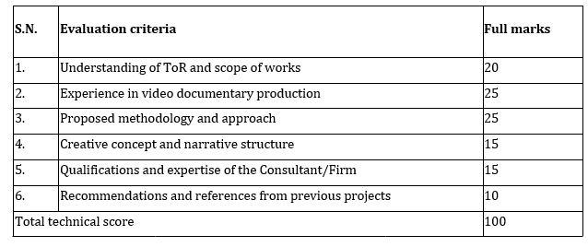

**APPLY TO:**

Interested candidates should submit their EOI with CV, a cover letter detailing their relevant experience, budget and a sample of previous work by**22 April 2025,** to [**samari.utthan@gmail.com**](https://gmail.com/). Qualified and committed Nepali individuals or firms are strongly encouraged to apply. The selected applicant will be invited for a final discussion and contract signing.