﻿﻿EXPRESSION OF INTEREST (EOI) FOR PARTNERSHIP
CONTEXT
For more than 30 years, Médecins du Monde (MdM), is France based international medical humanitarian organization. MdM currently works in 34 countries across all continents where it focuses on 5 priority areas: caring for the health of migrants and displaced persons, promoting sexual and reproductive health, combating HIV and reducing the harm and risks associated with drug use, crises and conflicts and environmental health.
MdM has worked in Nepal since 2001 in various topic such as Tuberculosis, HIV/AIDS, Sexual and Reproductive Health with Microfinance including emergency response during earthquake in Sindhupalchowk and flood in Terai. Since 2018 MdM has been focused on Nepal strategically on environment-health projects. MdM is working on Environmental Health to improve health status of informal waste workers (IWWs), mitigating their occupational risks and environmental exposure, improving access to information, and increasing access to health services, especially considering the COVID-19 pandemic. We are currently implementing “Healthy Waste Workers for Sustainable Waste Management” (HWW4SWM) project in Kathmandu Valley and Sisdole Landfill site. MDM-F also implementing “Healthy waste workers project” in Nepalgunj Banke to increase the access to decent and safe work opportunities of Waste Workers, promoting Occupational Health & Safety, Health care waste management and contributing to 3R strategy of waste reduction, we are implementing project “Healthy waste workers” for about 5 years.
MdM France invites EOI from the relevant Nepalese non-governmental organizations/ civil society actors for its potential partnership for approximately 3 years.
PROSPECTIVE PROJECT
Project Name: Supporting occupational and environmental health through health care system strengthening in Nepal (SOEH).
Expected duration: 3 years
Expected Geography: Kathmandu Valley, Nuwakot, Banke and Jajarkot districts.
Impact: Improving health outcomes by strengthening the health care system integrating OHS to deliver quality health services for vulnerable populations by their occupational and living conditions.
Objectives and outcomes of the project.
Objective 1: Mitigate environmental factors impacting the health of vulnerable populations, waste workers, farmers and urban dwellers areas in Nepal.
Objective 2: Support the local governments in promotion of resilient health system providing quality health care services including OHS integrated services.
Objective 3: Engage local government and communities in collaborative efforts to identify and address policy gaps related to environmental protection, aiming to support effective implementation initiatives in community.
The project intends to achieve the following outcomes by 2027
Outcome 1.1: Vulnerable people in harmful environments are better able to reduce the negative impacts on health and promote durable initiatives for the community.
Outcome 1.2: Vulnerable populations and affected communities have access to quality health care services integrating occupational health services.
Outcome 2: The capacity of health services is strengthened to offer a better preventive and curative response for people exposed to harmful environment (Urban dwellers, farmers & IWWs) and vulnerable communities.
Outcome 3.1: Collective action by the community and its advocates is reinforced alongside local and national authorities and structured to improve the prevention of risk associated with harmful environments
Outcome 3.2: Local government address environmental protection policy gaps, for healthy environment for target population.
Target beneficiaries:
The project intends to cater the following direct beneficiaries of the targeted area.
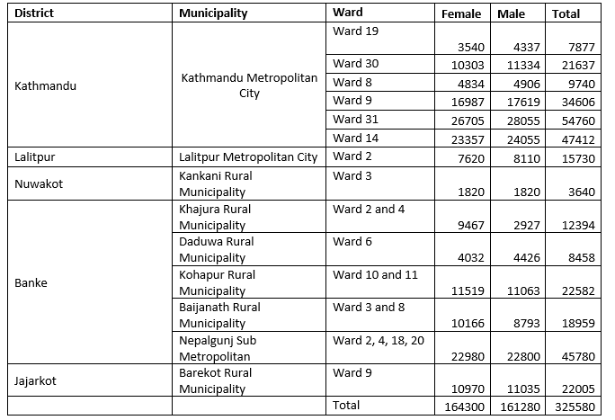
Final beneficiaries are also the communities of the targeted municipalities, around 3 to 4 million inhabitants.
MDM PERSPECTIVES:
As a medical humanitarian organization, MdM is committed to international solidarity, and has been caring for the most vulnerable populations at home and abroad. It has continued to highlight obstacles that exist in accessing health care and has secured sustainable improvements in health-for-all policies.
Those working for this independent organization do not solely dispense care and treatment but condemn violations of human dignity and rights and fight to improve matters for populations living in precarious situations.
Our action is built on the following six thematic areas:
- Sexual and Reproductive Health and Rights
- Harm reduction, to lessen the negative consequences of drug use and risky sexual practices
- Migration, Exile, Human Rights and Health
- Health and Environment
- Humanitarian Space (Emergencies and crises)
- Healthcare Systems
In addition, the three cross cutting approaches are as following:
- Mental health and psychosocial support
- Childhood vulnerability
- Gender-based approach.
The current project is based on thematic area “Environment and Health, Healthcare Systems and Sexual and Reproductive Health and Rights”.
MdM promotes environmental and public health sustainability which means all our interventions must be implemented in a manner that does not adversely affect the environment and public health.
CRITERIA FOR A PARTNER ORGANIZATION
- The organization should be competent civil society organization, and local non-governmental organization, duly registered or established and currently operating as per prevailing laws in Nepal. Preference will be given to the organizations established by or among the beneficiary groups and having technical competencies or proven experiences.
- The organization should not be a political party or affiliated to a political party.
- The organization’s operation might match with MdM values and applies the principles of participation, non-discrimination, accountability, and transparency within organization and programs
- Potential organization must have updated legal status (registration / renewal, up to date audits, tax clearance /exemption etc) as per the requirement of the government law of Nepal.
- The organization has adequate implementation capacities. Potential organization must have at least basic planning, monitoring, evaluation, reporting system in place and have a capacity to monitor and track the results of the project against its baseline.
- Potential organizations must have a proper system for good governance, ensuring government compliances, transparency and accountability towards rights holders, duty bearers and donors in their decisions and work.
- Proposed concept (EOI) should demonstrate realistic and relevant budget in terms of expected results and should have a clear link between the expected results, activity plan and the budget.
Note:
- MDM reserves the right to ask or obtain further details and documents from the shortlisted organizations during EOI evaluation and negotiation processes.
- MdM reserves all the right to reject/dismiss this EOI process without assigning any reasons to applicants.
- The Partnership is subject to availability of funding to MdM and approval of the project agreement by Social Welfare Council
HOW TO APPLY:
Interested or prospective NGOs/CSOs that comply with above-stated criteria may submit Expression of Interest (EOI) on specified format given below as Annex -1 and must not exceed 10 pages in PDF version with Times New Roman font, font size 12. Annex -1 will be provided upon request of interested candidates via email at info.mdmfrance@gmail.com.
Enclose the copy of organization registration /renewal certificate, statutes, organizational strategic plan, audit report, tax submission and updated organizational profile along with the filled up EOI format.
Interested NGOs may ask questions/queries if any via email at info.mdmfrance@gmail.com no later than 19th April 2024. Responses will be provided by email. NO TELEPHONIC ENQUIRES WILL BE ENTERTAINED.
EOI should be submitted via email at info.mdmfrance@gmail.com with the subject line “EOI – SOEH. ” no later than 17:00 hours on 28th April 2024 Nepal Standard Time.

