﻿﻿Project Name: Financial Inclusion for Marginalized Women in Nepal
End-line Survey
Terms of Reference
Nature of assignment | Consulting Assignment
Consultancy Duration | May 02 to June 30 2024
Published Date: | 16 April 2024
1. Project background and information
Background
Habitat for Humanity Nepal (Habitat Nepal) as part of Habitat for Humanity International network, is a non-governmental organization that has been in existence for 26 years in Nepal. Habitat Nepal has worked to fulfil a vision “A world where everyone has a decent place to live”. Habitat Nepal serves the most vulnerable through the provision and promotion of decent housing, water & sanitation, housing microfinance and advocacy on land & housing rights with an emphasis on gender equality.
With the financial support of Jersey Overseas Aid (JOA), Habitat Nepal and Sahara Nepal have been implementing a four-year project called “Financial Inclusion for Marginalized Women in Nepal”. The project was designed to sustainably improve financial literacy knowledge and reduce poor housing conditions amongst low-income households in Eastern Nepal, particularly in Jhapa, Morang, Saptari and Udayapur districts. In this regard, Habitat Nepal is seeking to recruit an experienced consultant (firm/individual) to conduct an endline survey of the project. This endline survey aims to find out the outcome and impact indicators values created through the activities that were conducted during the last four years of the project. The endline survey should start ideally from April 1 and the report will be submitted as an input to final evaluation.
This Terms of Reference (TOR) defines the work to be carried out by an external consultant. It provides a brief outline of the project, objectives and the scope of work.
Project Information
Project Title | Financial Inclusion for Marginalized Women in Nepal
Project Summary | The project is implemented by a consortium including Habitat for Humanity Great Britain (HFHGB), Habitat for Humanity Nepal and Sahara Nepal (a well-known microfinance institution in the country). The overall project goal is: “Low-income women have improved financial security and safer housing through improved access to financial services in Nepal”.  By the end of the project, the project will equip women with financial literacy and knowledge of available microfinance products, which will result in the increased access to housing microfinance loans from formal financial services. Through the technical assistance for product development and support for training and capacity building activities from this project, the partner MFIs will We build strength, stability, self-reliance and shelter become more responsive and accountable to their service delivery for the community willing to apply flexibility in housing loan acquisition.
Project Objective | Increasing financial inclusion with a focus on housing loans is crucial to help low-income women out of poverty in rural Nepal.
Project Outcomes | - Low-income families have increased capacity and awareness on how to access microfinance loans for financing and planning their home improvements.  - MFIs have increased capacity to offer client centric housing loans that meet the needs of clients from marginalized, low-income communities
Project Outputs | - Financial literacy training classes are held for 6,000 women to increase knowledge and capacity to access and use microfinance loans.  - 50,000 women and men reached through awareness-raising campaigns, including youth-led events, on the availability of microfinance products and services and the importance of safe housing.  - 5 marketing strategies developed and put into action by 5 MFIs.  - 2 MFIs supported in adopting Digital Financial Services to serve their clients better.  - 5 MFI partners received institutional capacity building training.  - Partner MFIs’ advocacy capacity strengthened for better regulatory environment to mainstream housing microfinance.  - 112,000 MFI clients received housing loans
Project Location | 4 districts of Eastern Nepal: Jhapa, Morang, Saptari and Udayapur
Project Period | 4 years (1 August 2020 to 31 July 2024)
Beneficiaries | The estimated reach is indicated below.  - Direct end beneficiaries: 112,000 women members of partner MFIs receive housing loan.  - Frontline workers: 800 workers or volunteers who received training / support to enable them to assist the beneficiaries.  - Other Groups Benefiting Directly: 448,000 family members of the direct beneficiaries.
Implementing Partners | Habitat for Humanity Nepal and Sahara Nepal with support from Habitat for Humanity Great Britain (HFHGB).
2. Objectives
The main objective of TOR is to conduct an endline survey to assess the value of outcome and impact indicators. This involves comparing these values with baseline and mid-line values of the indicators and with a designated comparison group.
The specific objectives are:
- to assess is there any outcome and impact of house improvement with MHF on health, education and social economic condition of the homeowners.
- to assess any outcome and impact of financial literacy training on financial behavior of the households who received financial literacy training.
- to assess knowledge and awareness level of households on safe shelter.
- to assess effectiveness of awareness raising activities conducted to raises awareness of target beneficiaries on financial literacy and safe shelter.
3. Scope of work
The scope of the endline survey will look at the four districts the project took place in during the implementation period between August 1, 2020 to July 31, 2023. It aims to gather input and feedback from various stakeholders, including:
- MFIs clients that received housing micro finance loans.
- Households that participated in financial literacy training.
- Participants who took part in, or were exposed to, our awareness raising activities, including: ., video screening, rally, booklet/pamphlet distribution, broadcasting through radio, electrical signpost advertisement, public interaction on FLT and safe shelter, collaboration with school/club/ self-help group, training to end users, project implemented since August 1, 2020 to July 31, 2023.
- Representatives from the four MFIs involved in the project, namely: Sahara Nepal Saving and Credit Cooperative Limited, Jeevan Bikash Laghubitta Bittiya Sanstha Limited, Forward Microfinance Laghubitta Bittiya Sanstha Limited
By engaging with these stakeholders, the survey aims to comprehensively assess the outcomes and impacts of the project within the specified timeframe and geographic scope.
Following are the participants of the various interventions implementing by the project in four districts with 4 MFIs such as Sahara Nepal Saving and Credit Cooperative Limited, Jeevan Bikash Laghubitta Bittiya Sanstha Limited, Forward Microfinance Laghubitta Bittiya Sanstha Limited. Mahuli Laghubitta Bittiya Sanstha Limited.
- Micro housing loans distribution by four MFIs through all their branches.
- Financial literacy training conducted in 20 Municipalities (Jhapa-6, Morang-5, Saptari-5 Udaypur-4)
- Following awareness raising activities conducted in 20 Municipalities (Jhapa-6, Morang-5, Saptari-5 Udaypur-4)
  - Rally
  - Open air video screening
  - Booklet/pamphlet distribution
  - Public interaction on FLT and safe shelter
  - Collaboration with school/club/self-help group
  - Training to end users.
4. Methodology
Based on the objectives and scope of work the consultant individual/firm should propose an appropriate survey methodology, experimental design framework and sample size to provide a comprehensive overview of the project outcome and impact on its beneficiaries.
5. Deliverables expected from consultant
The consultant should deliver an electronic copy of the following documents:
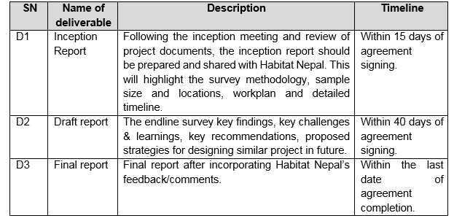

6. Timeframe
This assignment should start from May 2, 2024, and should be completed by June 30, 2024
7. Specific inputs from Habitat Nepal
The selected firm will have access to the following documents from Habitat Nepal and logistical support.
- Project proposal approved by JOA.
- Project log frame
- Project theory of change
- Baseline survey report
- Financial literacy training package
- Financial literacy awareness raising guideline.
- Various IEC and mass media materials developed for project implementation.
- Periodic report submitted to JOA.
- Mid-line survey report
- Communicate and coordinate with implementing partner Sahara Nepal, MFIs and the consultant.
- Support for logistic arrangements for the consultant.
- Review tools/guide/questionnaire and provide feedback.
- Review draft report and provide feedback.
8. Queries on ToR
In case of any confusion or clarification, the firms can send their issues at asingh@habitatnepal.org or call at +977-9801073688.
9. Team composition
The firm should propose the following team member:
- Team Leader having experiences in quantitative and qualitative assessment through survey such as baseline, midline and endline.
- Financial literacy expert having community awareness raising knowledge.
- Statistician
The proposed team members should have 5+ years demonstrating relevant experiences in monitoring and evaluating of community support, financial inclusion and other microfinance projects.
10. Financial proposal
Financial proposal should be presented in the following format. If you feel some headings are missing, you can add accordingly.
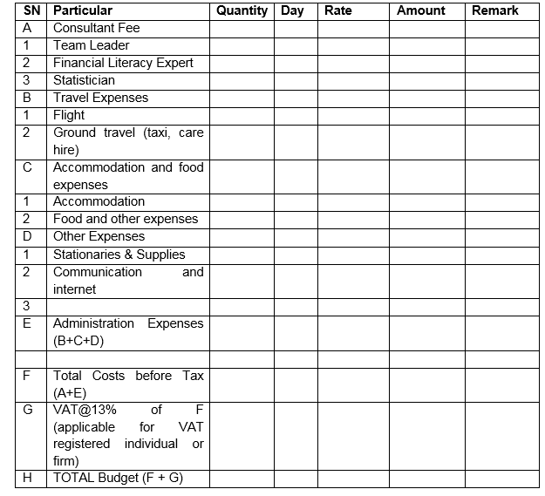

Note:
- If proposal is submitted by PAN registered firm or individual person, Habitat Nepal will withhold applicable Tax Deduction at Source (TDS) of 15% of the total budget of Serial Number F in the above table.
- If the firm or individual is registered in VAT, Habitat Nepal will withhold applicable TDS as per rule of Government of Nepal.
11. Ethical protocols
In accordance with its foundational mission principles, Habitat for Humanity Nepal is committed to the highest ethical standards and opposes all forms of discrimination, exploitation, and abuse. We intend to create and maintain a work and living environment that is safe, productive, and respectful for our colleagues and for all we serve.
We require that all staff and representatives (consultants, contractors, vendors/suppliers, interns, volunteers, agents, and implementing partner organizations) take seriously their ethical responsibilities to Safeguarding (Child Protection, Prevention of Sexual Exploitation Harassment, and Abuse) our intended beneficiaries, their communities (especially children), and all those with whom we work.
Abiding with the organization, the consultancy service has responsibilities to maintain an environment that prevents harassment, sexual exploitation, and abuse, safeguards the rights of beneficiaries and community members (especially children), and promotes the implementation of Habitat for Humanity’s code of conduct.
Throughout the assignment engagements, the consultants are expected to adhere to Habitat Nepal’s code of conduct including the safeguarding policy ensuring that all measures are taken to protect the rights, safety, and welfare of the individuals and communities involved.
The consultant/s should guarantee that the analysis is technically accurate and reliable and is conducted in a transparent and impartial manner. All products resulting from this analysis will be owned by Habitat. The consultant will not be allowed, without prior authorization in writing, to present any of the results or use any product resulting from the analysis as his or her own or for private publication purposes.
12. Documents required:
- Technical and Financial proposal
- Firm/company profile with a list of past clients in related assessment.
- A copy of firm/company registration certificate
- A copy of PAN/VAT registration certificate
- A copy of tax clearance certificate of most recent fiscal year
- CV of experts proposed.
13. To apply
Interested individuals or firms/companies should submit their technical and financial proposal including testimonials/certificates at procurement@habitatnepal.org or hardcopy in a sealed/closed envelope at Habitat for Humanity Nepal, House No. 126, New Colony Marg, Dhobighat, Lalitpur, Nepal.
Application deadline: April 23, 2024

